Black Box Test Plan: Bunco Game Application

Objective: The purpose of this black box testing is to verify that the Bunco Game Application satisfies the criteria and operates as intended based just on inputs and anticipated outputs, without taking into account the specifics of the internal implementation.

Test Items:1. Start Game 2. Roll Dice 3. Score Calculation 4. End Round 5. End Game

**Test Cases**

Test Environment:To verify compatibility, the Bunco Game Application will be tested across a range of screens and resolutions.

Testing Tools:

1. 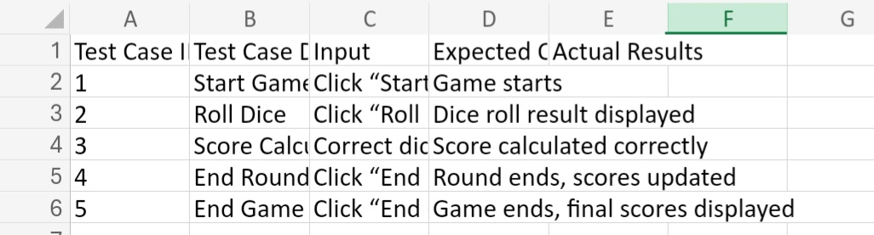Emulators for various smartphone operating systems
2. Actual equipment for hands-on testing
3. A bug tracking system to document any problems found when conducting testing.

Execution of Tests:

1. Carry out each test scenario in turn.
2. Enter the observed outcomes in the column labeled “Actual Results.”
3. Bring up any differences between the anticipated and realized outcomes.
4. After fixes are applied, retest the failed test cases.

Criteria for Test Completion:

1. Every test case has been run.
2. For every test case, expected and actual outputs coincide.
3. Every issue found has been fixed and successfully retested.

Restrictions:   
It requires a steady network connection in order to use any online capabilities.   
Dependencies: - The Bunco Game Application is accessible for testing.